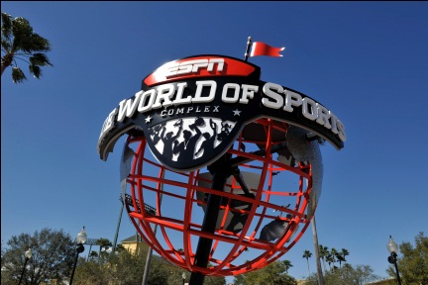 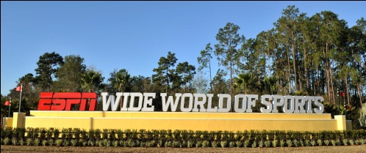

**AAU Men’s International Fastpitch Championship Filling Fast**

**ESPN Wide World of Sports at Walt Disney World Resort in Orlando, FL**

**January 24-29**

Warm weather. Hot teams. World-class professional facilities – no youth softball recreational facilities here! Professionally planned and managed. Broadcast. Long standing, long respected. And filling fast. Don’t miss your chance.

With teams registered from Bahamas, Jamaica, throughout South America, and North America, the international flavor of this tournament is undeniable. Flags of every color will be flying as the top teams in the world convene at the renowned ESPN Wide World of Sports. AAU and the incomparable Walt Disney World Resort stand ready to welcome you for the best fastpitch experience available anywhere on the planet.

If you are a player in need of a team, or a team in need of a player, contact Debra Horn, [debra@aausports.org](mailto:debra@aausports.org). She will maintain a list to match players’ and teams’ needs.

Want a taste of what is offered? Check out this video: <http://bit.ly/QKfQHo>.

Now is the peak of the booking season and slots are falling away rapidly. Don’t be left out in the January cold. Remember teams are accepted on a first-come, first-served basis and applications are coming in fast. Send yours in today.

For more information or for an entry package, visit [www.aaufastpitch.org](http://www.aaufastpitch.org) or contact Debra Horn, [debra@aausports.org](mailto:debra@aausports.org) or Ken Hackmeister, iscken@comcast.net.